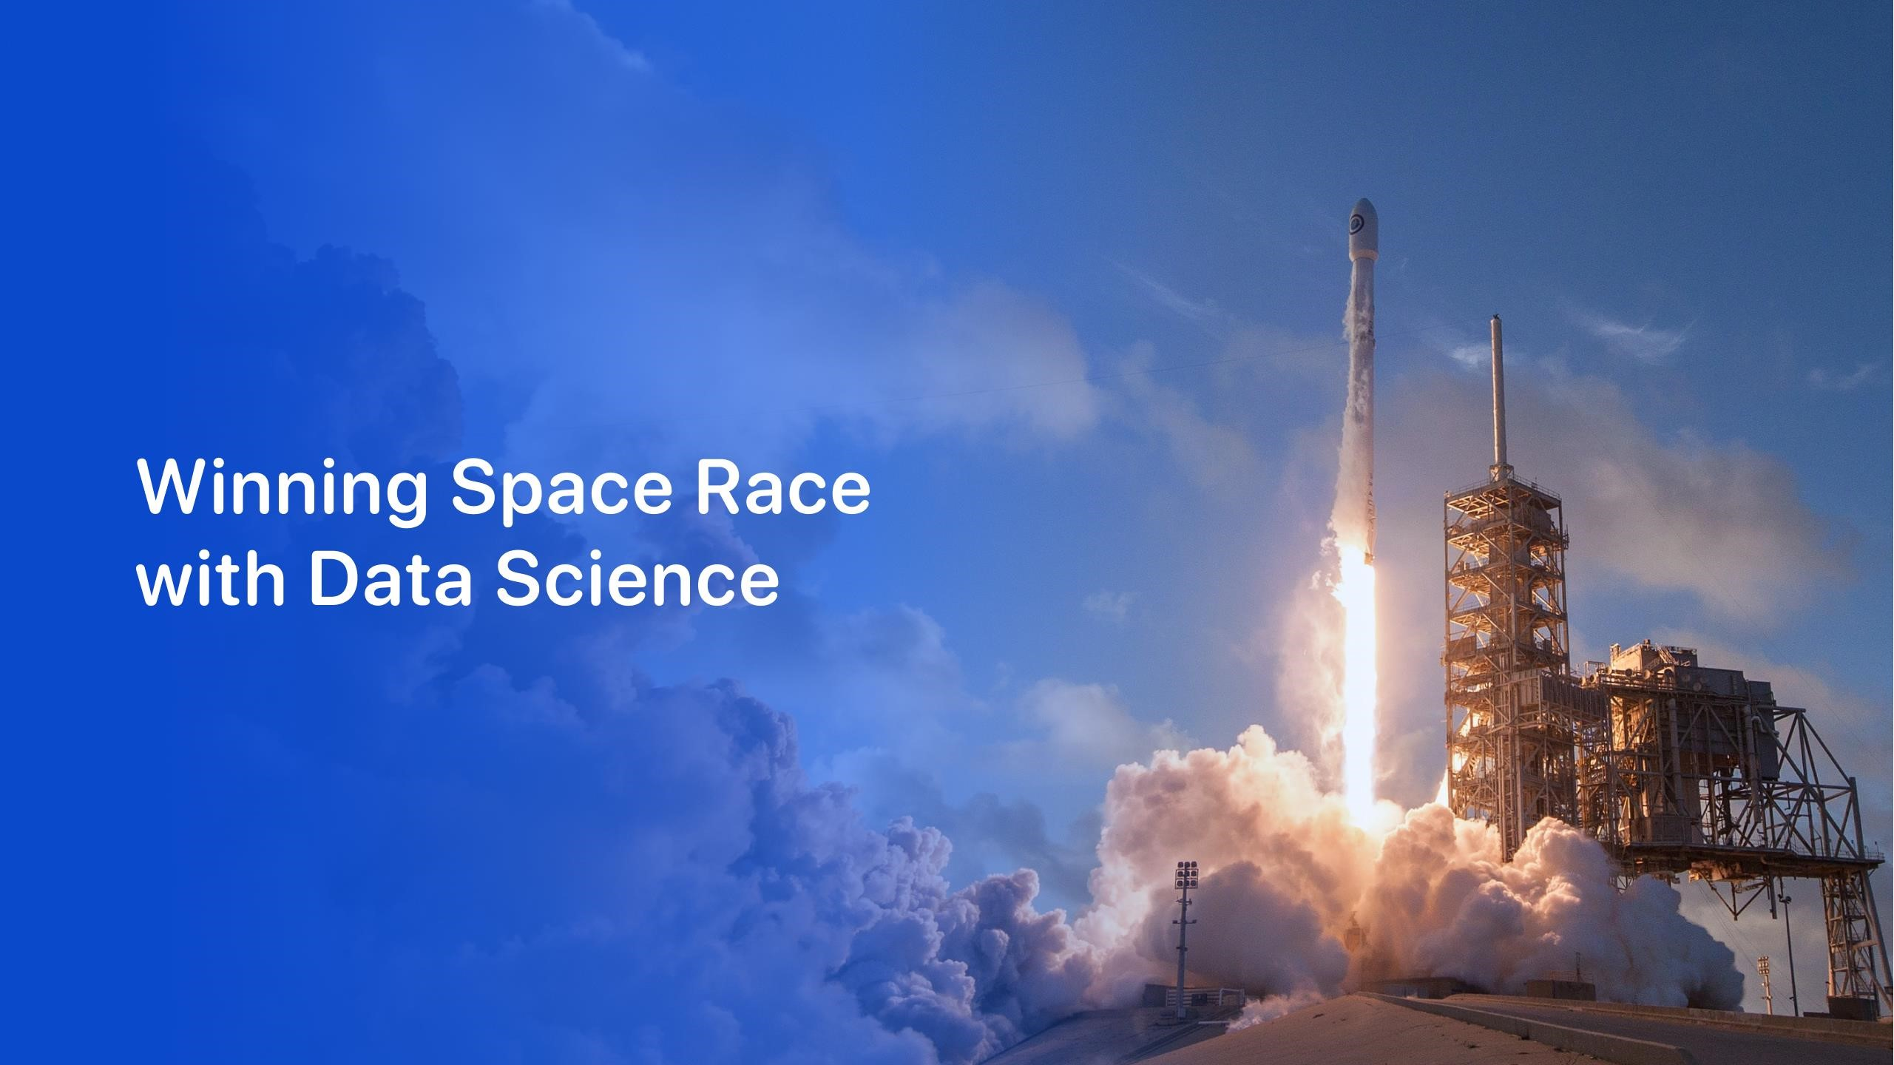

Angel Bush

May 3, 2023



•

Executive Summary

•

Introduction

•

Methodology

•

Results

•

Conclusion

•

Appendix

Outline



3

•

Summary of methodologies

-

Data Collection through API

-

Data Collection with Web Scraping

-

Data Wrangling

-

Exploratory Data Analysis with SQL

-

Exploratory Data Analysis with Data Visualization

-

Interactive Visual Analytics with Folium

-

Machine Learning Prediction

•

Summary of all results

-

Exploratory Data Analysis result

-

Interactive analytics in screenshots

-

Predictive Analytics result

Executive Summary



Introduction

•

Project background and context

Space

X

advertises

Falcon

9

rocket

launches

on

its

website

with

a

cost

of

62

million

dollars

;

other

providers

cost

upward

of

165

million

dollars

each,

much

of

the

savings

is

because

Space

X

can

reuse

the

first

stage

.

Therefore,

if

we

can

determine

if

the

first

stage

will

land,

we

can

determine

the

cost

of

a

launch

.

This

information

can

be

used

if

an

alternate

company

wants

to

bid

against

space

X

for

a

rocket

launch

.

This

goal

of

the

project

is

to

create

a

machine

learning

pipeline

to

predict

if

the

first

stage

will

land

successfully

.

•

Problems you want to find answers

-

What factors determine if the rocket will land successfully?

-

The interaction amongst various features that determine the success rate of a successful

landing.

-

What operating conditions needs to be in place to ensure a successful landing program.



5



Executive Summary

•

Data collection methodology:

•

Data was collected using SpaceX API and web scraping from Wikipedia.

•

Perform data

wrangling

•

One

-

hot encoding was applied to categorical features

•

Perform exploratory data analysis (EDA) using visualization and

SQL

•

Perform interactive visual analytics using Folium and

Plotly

Dash

•

Perform predictive analysis using classification models

•

How to build, tune, evaluate classification models

Methodology



•

The

data

was

collected

using

various

methods

-

Data

collection

was

done

using

get

request

to

the

SpaceX

API

.

-

Next,

we

decoded

the

response

content

as

a

Json

using

.

json()

function

call

and

turn

it

into

a

pandas

dataframe

using

.

json_normalize

()

.

-

We

then

cleaned

the

data,

checked

for

missing

values

and

fill

in

missing

values

where

necessary

.

-

In

addition,

we

performed

web

scraping

from

Wikipedia

for

Falcon

9

launch

records

with

BeautifulSoup

.

-

The

objective

was

to

extract

the

launch

records

as

HTML

table,

parse

the

table

and

convert

it

to

a

pandas

dataframe

for

future

analysis

.

Data Collection



•

We used the get request to the

SpaceX API to collect data, clean

the requested data and did some

basic data wrangling and

formatting.

•

The link to the notebook is

https://github.com/chuksoo/IBM

-

Data

-

Science

-

Capstone

-

SpaceX/blob/main/Data%20Collect

ion%20API.ipynb.

Data Collection

–

SpaceX API

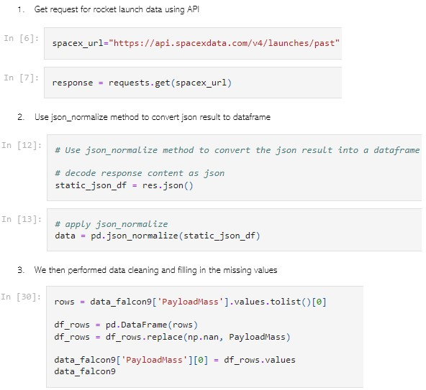

•

We applied web scrapping to

webscrap Falcon 9 launch records

with BeautifulSoup

•

We parsed the table and converted

it into a pandas dataframe.

•

The link to the notebook is

https://github.com/chuksoo/IBM

-

Data

-

Science

-

Capstone

-

SpaceX/blob/main/Data%20Collect

ion%20with%20Web%20Scraping

.ipynb.

Data Collection

-

Scraping

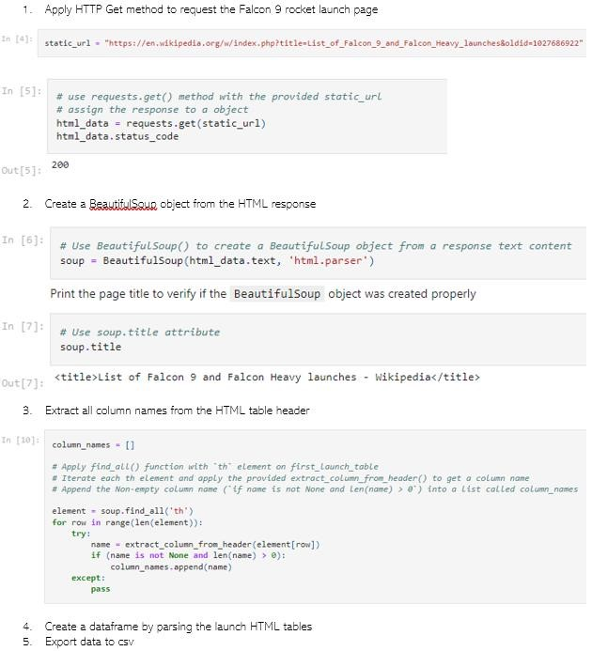

•

We performed exploratory data analysis

and determined the training labels.

•

We calculated the number of launches at

each site, and the number and occurrence

of each orbits

•

We created landing outcome label from

outcome column and exported the results

to csv.

•

The link to the notebook is

https://github.com/chuksoo/IBM

-

Data

-

Science

-

Capstone

-

SpaceX/blob/main/Data%20Wrangling.ip

ynb.

Data Wrangling

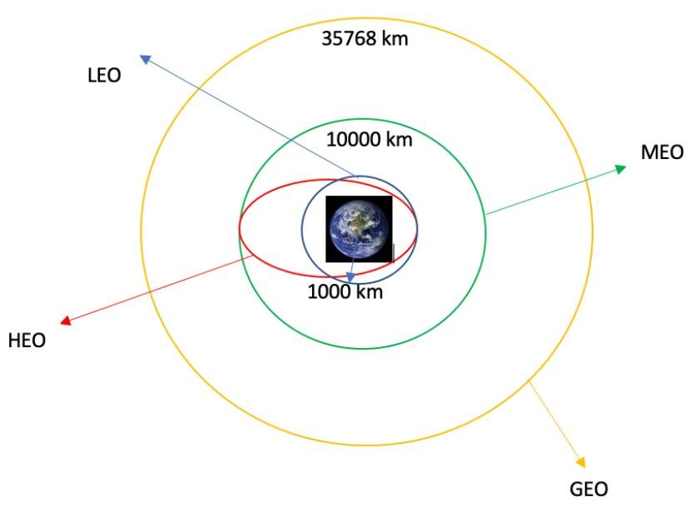

11

•

We explored the data by visualizing

the relationship between flight

number and launch Site, payload and

launch site, success rate of each orbit

type, flight number and orbit type, the

launch success yearly trend.

EDA with Data Visualization

•

The link to the notebook is

https://github.com/chuksoo/IBM

-

Data

-

Science

-

Capstone

-

SpaceX/blob/main/EDA%20with%20D

ata%20Visualization.ipynb

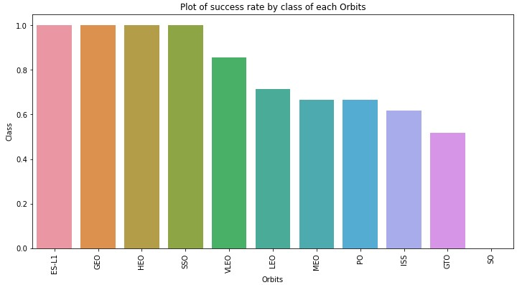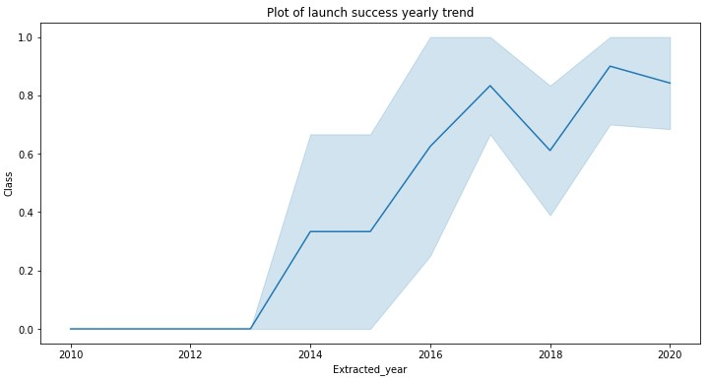

•

We loaded the SpaceX dataset into a PostgreSQL database without leaving

the

jupyter

notebook.

•

We applied EDA with SQL to get insight from the data. We wrote queries to

find out for instance:

-

The names of unique launch sites in the space mission.

-

The total payload mass carried by boosters launched by NASA (CRS)

-

The average payload mass carried by booster version F9 v1.1

-

The total number of successful and failure mission outcomes

-

The failed landing outcomes in drone ship, their booster version and launch site names.

•

The link to the notebook is

https://github.com/chuksoo/IBM

-

Data

-

Science

-

Capstone

-

SpaceX/blob/main/EDA%20with%20SQL.ipynb

EDA with

SQL



•

We marked all launch sites, and added map objects such as markers, circles, lines to

mark the success or failure of launches for each site on the folium map.

•

We assigned the feature launch outcomes (failure or success) to class 0 and 1.i.e., 0

for failure, and 1 for success.

•

Using the color

-

labeled marker clusters, we identified which launch sites have

relatively high success rate.

•

We calculated the distances between a launch site to its proximities. We answered

some question for instance:

-

Are launch sites near railways, highways and coastlines.

-

Do launch sites keep certain distance away from cities.

Build an Interactive Map with Folium



•

We built an interactive dashboard with Plotly dash

•

We plotted pie charts showing the total launches by a certain sites

•

We plotted scatter graph showing the relationship with Outcome and Payload

Mass (Kg) for the different booster version.

•

The link to the notebook is

https://github.com/chuksoo/IBM

-

Data

-

Science

-

Capstone

-

SpaceX/blob/main/app.py

Build a Dashboard with Plotly Dash



•

We loaded the data using

numpy

and pandas, transformed the data, split our

data into training and testing.

•

We built different machine learning models and tune different

hyperparameters using

GridSearchCV

.

•

We used accuracy as the metric for our model, improved the model using

feature engineering and algorithm tuning.

•

We found the best performing classification model.

•

The link to the notebook is

https://github.com/chuksoo/IBM

-

Data

-

Science

-

Capstone

-

SpaceX/blob/main/Machine%20Learning%20Prediction.ipynb

Predictive Analysis (Classification)



•

Exploratory data analysis results

•

Interactive analytics demo in screenshots

•

Predictive analysis results

Results





•

From the plot, we found that the larger the flight amount at a launch site, the greater

the success rate at a launch site.

Flight Number vs. Launch

Site

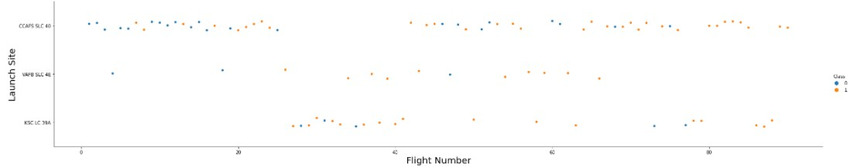

Payload vs. Launch Site

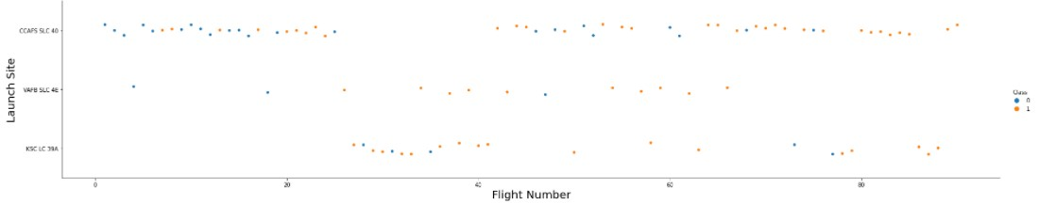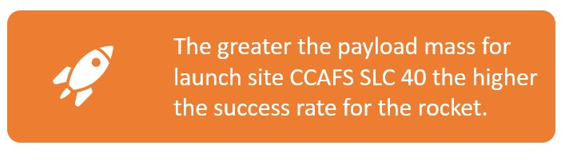

19

# Success Rate vs. Orbit Type

• From the plot, we can see that ES-L1, GEO, HEO, SSO, VLEO had the most success rate.

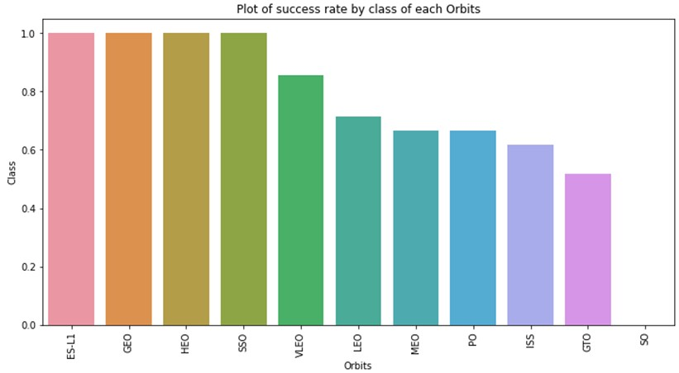

20



21

•

The plot below shows the Flight Number vs. Orbit type. We observe that in the LEO

orbit, success is related to the number of flights whereas in the GTO orbit, there is

no relationship between flight number and the orbit.

Flight Number vs. Orbit Type

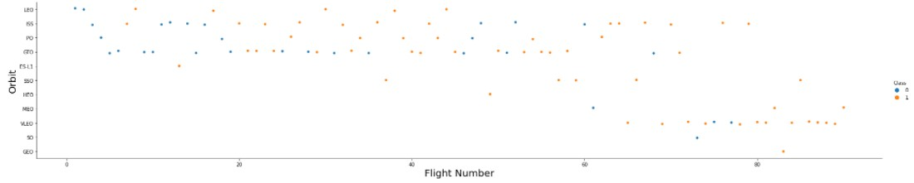

22

•

We can observe that with heavy payloads, the successful landing are more for PO,

LEO and ISS orbits.

Payload vs. Orbit

Type

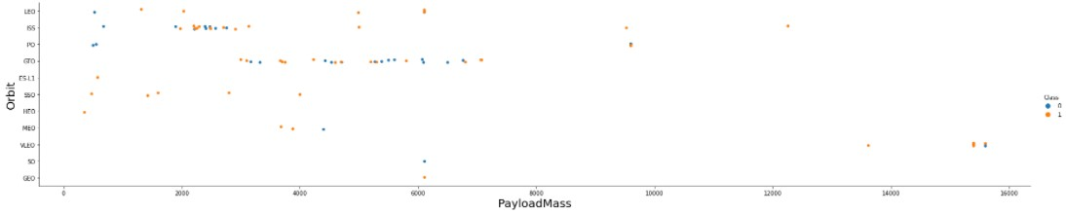

# Launch Success Yearly Trend

• From the plot, we can observe that success rate since 2013 kept on increasing till 2020.



23

# All Launch Site Names

• We used the key word DISTINCT to show only unique launch sites from the SpaceX data.

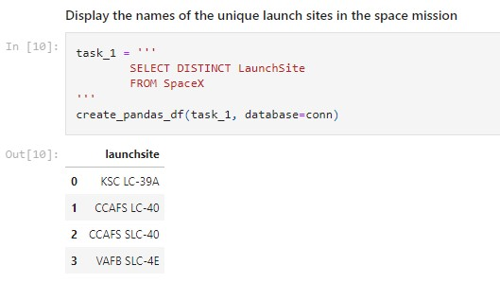

24



25

•

We used the query above to display 5 records where launch sites begin with

`CCA`

Launch Site Names Begin with 'CCA'

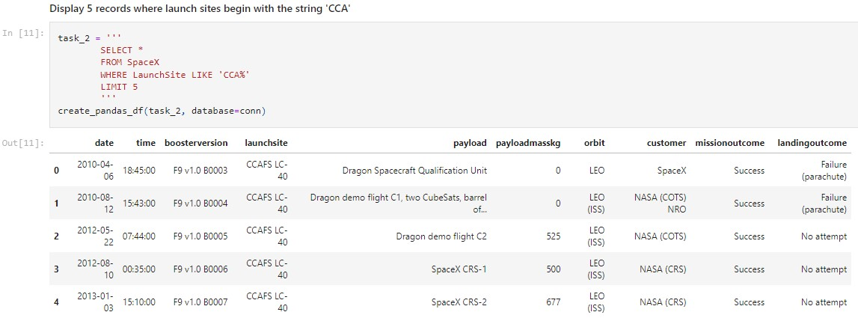

26

•

We calculated the total payload carried by boosters from NASA as 45596

using the query below

Total Payload Mass

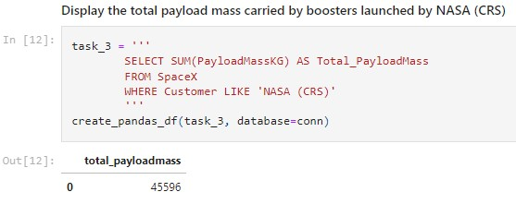

# Average Payload Mass by F9 v1.1

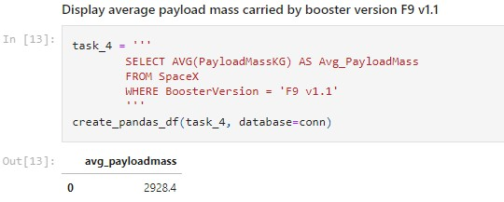

27

• We calculated the average payload mass carried by booster version F9 v1.1 as

2928.4

## First Successful Ground Landing Date

* We observed that the dates of the first successful landing outcome on

ground pad was 22nd December

2015

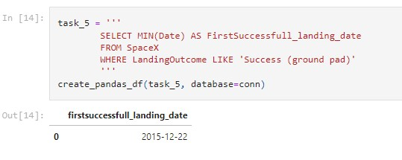

* We used the WHERE clause to filter for boosters which have successfully landed on drone ship and applied the AND condition to determine successful landing with payload mass greater than 4000 but less than 6000

Successful Drone Ship Landing with Payload between

4000

and

6000

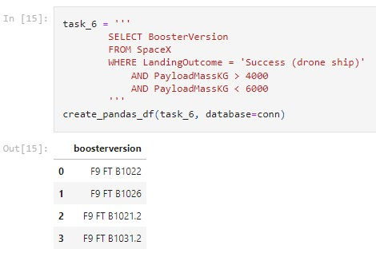

Total Number of Successful and Failure

Mission

Outcomes

•

We used wildcard like ‘%’ to

filter for

WHERE

MissionOutcome

was a success or a failure.

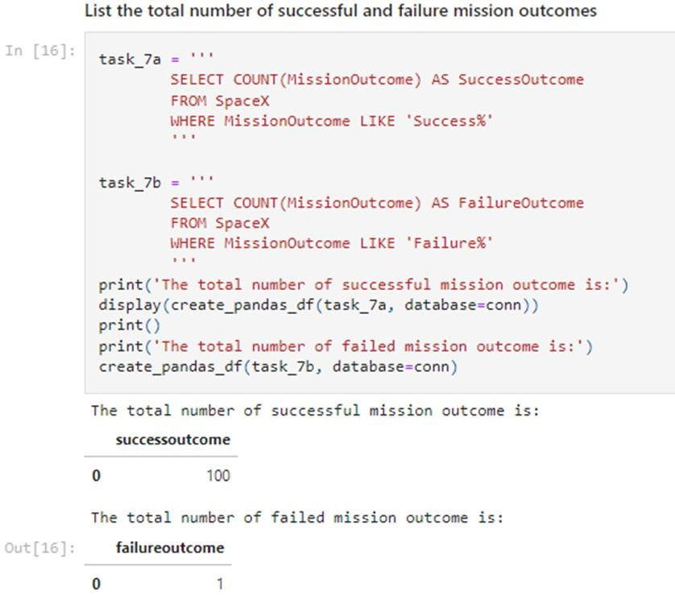

Boosters Carried

Maximum

Payload

•

We determined the booster that

have carried the maximum

payload using a subquery in the

WHERE

clause and the

MAX()

function.

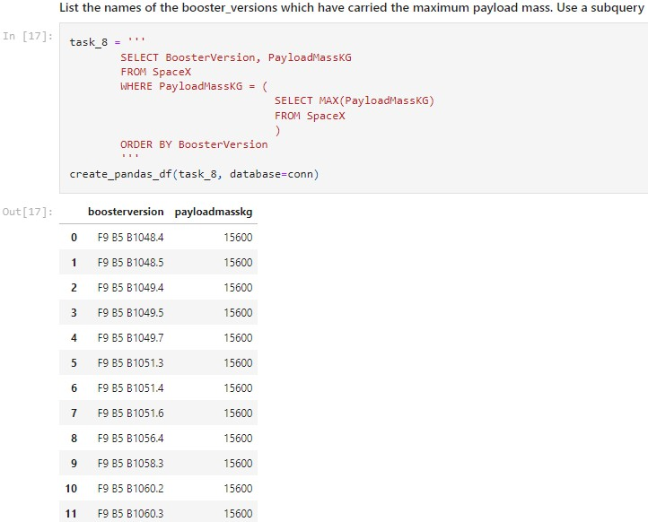

31



32

•

We used a combinations of the

WHERE

clause,

LIKE

,

AND

, and

BETWEEN

conditions to filter for failed

landing outcomes in drone ship, their booster

versions, and

launch site names for year 2015

2015

Launch Records

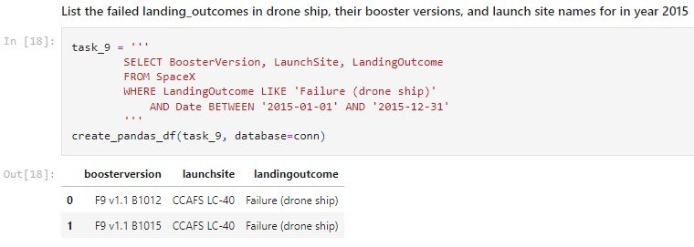

and the COUNT of landing

Rank Landing Outcomes Between 2010

-

06

-

04

and

2017

-

03

-

20

•

We selected Landing outcomes

outcomes from the data and

used the

WHERE

clause to filter

for landing outcomes

BETWEEN

2010

-

06

-

04

to

2010

-

03

-

20.

•

We applied the

GROUP BY

clause

to group the landing outcomes

and the

ORDER BY

clause to

outcome in descending order.

33

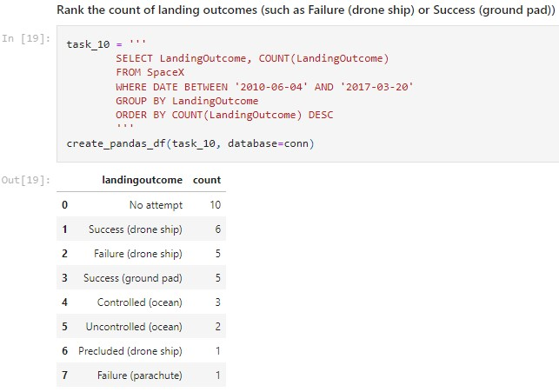

order the grouped landing



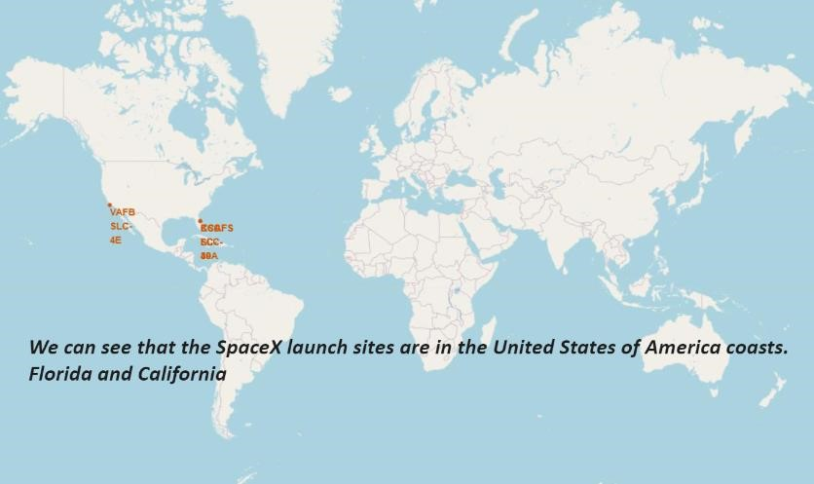

All launch sites global map markers

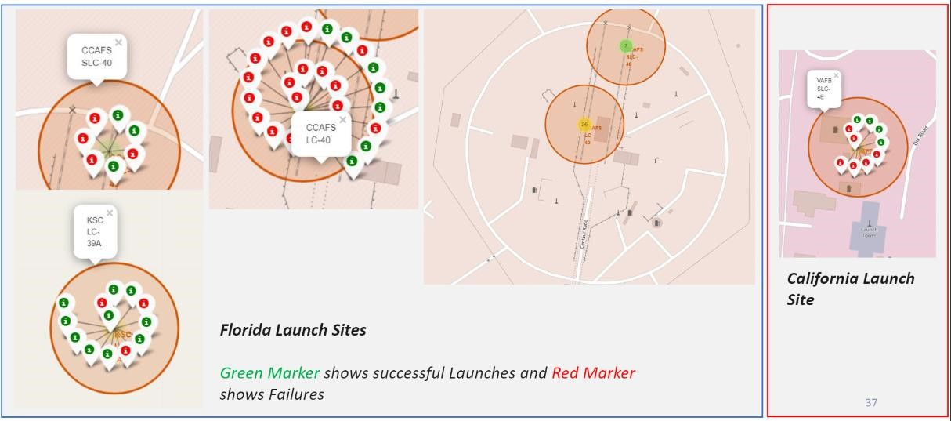

Markers showing launch sites with color labels

# Launch Site distance to landmarks

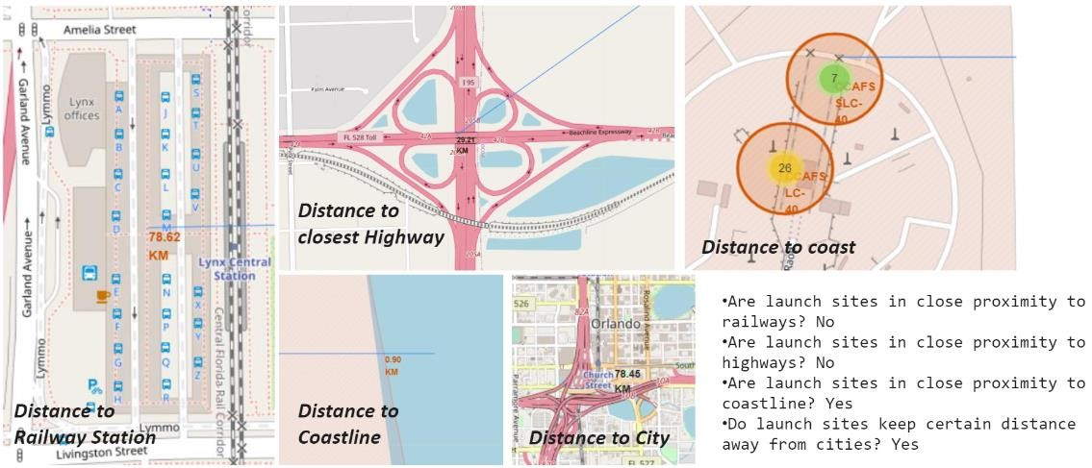



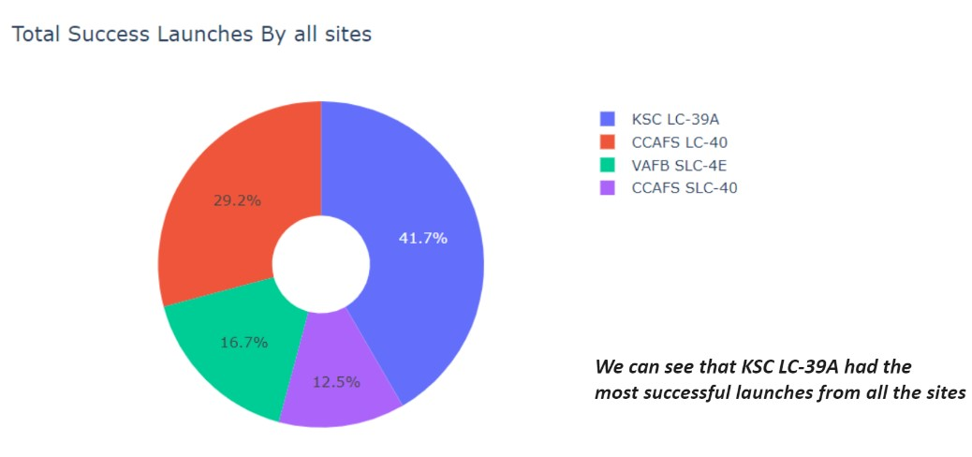

39

Pie chart showing the success percentage achieved by each launch site

Pie chart showing the Launch site with the highest launch success ratio

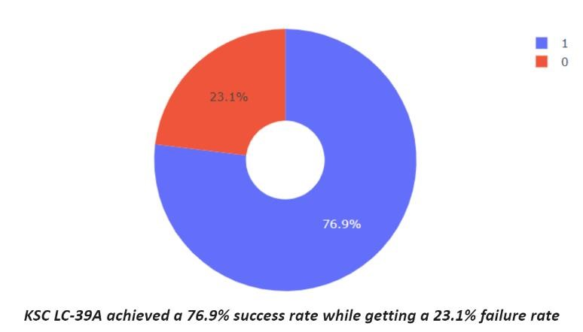

40

Scatter plot of Payload vs Launch Outcome for all sites, with different payload selected in the range slider

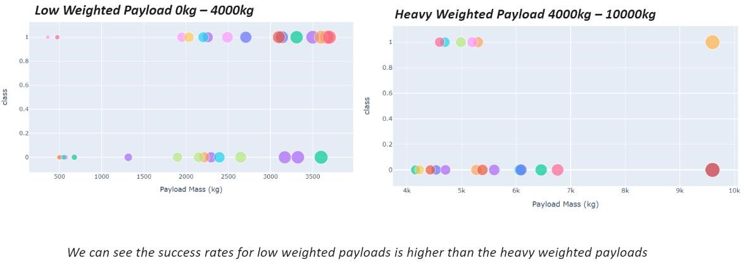

41





Classification

Accuracy

•

The decision tree classifier is the model with

the highest classification accuracy

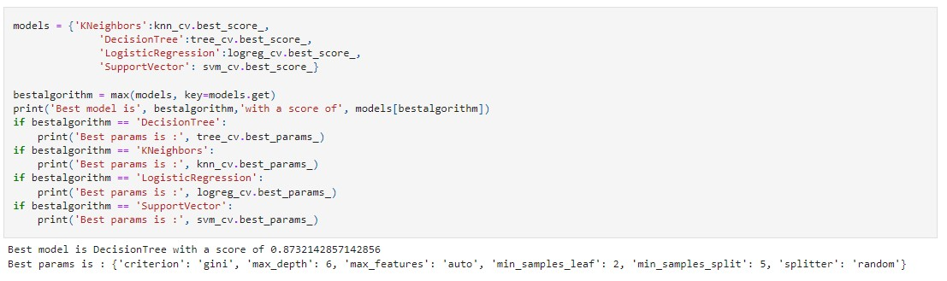

43



44

•

The confusion matrix for the decision tree

classifier shows that the classifier can

distinguish between the different classes.

The major problem is the false positives .i.e.,

unsuccessful landing marked as successful

landing by the classifier.

Confusion Matrix

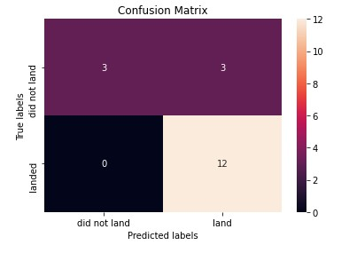

45

We can conclude that:

•

The larger the flight amount at a launch site, the greater the success rate at a launch

site.

•

Launch success rate started to increase in 2013 till 2020.

•

Orbits

ES

-

L1, GEO, HEO, SSO, VLEO had the most success rate.

•

KSC LC

-

39

A had the most successful launches of any sites.

•

The Decision tree classifier is the best machine learning algorithm for this task.

Conclusions

